**THE IMPORTANT OF MEAT’S CHICKENS.**

**Chicken meat** provides **vitamins** mainly from the B complex, including Niacin or **vitamin** B3, which is essential for the metabolism of fats and sugars in the body, as well as for maintaining healthy cells. It also contains minerals such as magnesium, potassium, phosphorus and zinc.

**To human.**

**Meat** represents an excellent source of the majority of hydrophilic **vitamins**, and it is the ideal dietary source of **vitamin** B12. The amounts of B-group **vitamins** (e.g. niacin, **vitamin** B6, and pantothenic acid) in **poultry** are very similar to those of other **meats** and do not significantly diminish during cooking.

**THE IMPORTANT OF EGG’S CHICKENS.**

**Eggs** have been eaten by **humans** for thousands of years. The female animals of many different species produce **eggs**, but by far the most common choice for consumption is the **egg** of the **chicken**.  
...  
**Below is a list of nutrients found in eggs:**

* **vitamin** A.
* **vitamin** B-2.
* **vitamin** B-12.
* **vitamin** B-5.
* **vitamin** D.
* **vitamin** E.
* biotin.
* Choline
* Iodine
* Iron
* lutein and zeaxanthin
* phosphorus
* Protein
* Selenium

Fast facts on eggs:

* Eggs are considered to be one of the best sources of protein available.
* Around 9 percent of an egg's content is fat, found almost exclusively in the yolk.
* Eggs are known for containing [cholesterol](https://www.medicalnewstoday.com/articles/9152.php).
* They are one of the most commonly consumed animal products in the world.

**Benefits**

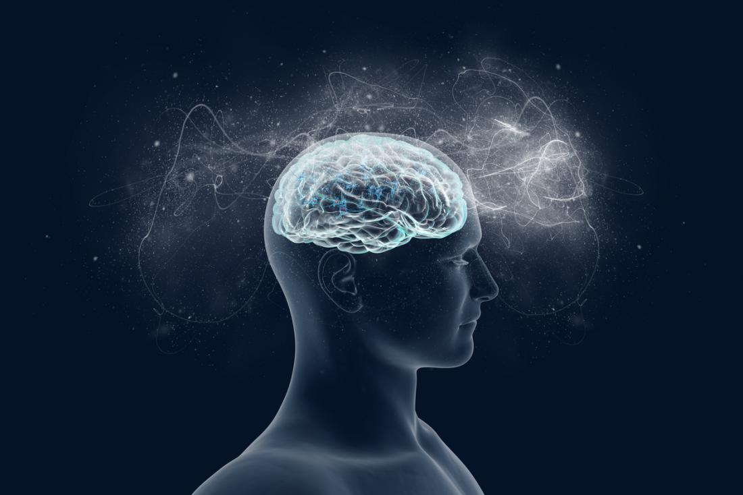

Nutrients contained within eggs are beneficial for brain cells and promote healthy brain function.

There are several health benefits that can be derived from eggs, including:

* **Strong muscles:** The protein within eggs helps keep muscles working well while slowing the rate at which they are lost.
* **Brain health:** Eggs contain vitamins and minerals that are needed for the regular functioning of cells, including the brain, nervous system, memory, and metabolism.
* **Good energy production:**Eggs contain all the daily vitamins and minerals that are needed to produce energy in all the cells of the body.
* **A healthy immune system:**Vitamin A, vitamin B-12, and [selenium](https://www.medicalnewstoday.com/articles/287842.php) are key to keeping the immune system healthy.
* **Lower risk of heart disease:**Choline plays an important part in breaking down the amino acid homocysteine, which is associated with the development of [heart disease](https://www.medicalnewstoday.com/articles/237191.php).
* **Healthful pregnancy:** Some nutrients within eggs help to prevent congenital disabilities, such as spina bifida.
* **Eyesight:**Lutein and zeaxanthin help to prevent [macular degeneration](https://www.medicalnewstoday.com/articles/152105.php), the leading cause of age-related blindness. Other vitamins also promote good vision.
* **Weight loss and maintenance:** The high quality of protein within eggs might help keep people energized and feeling fuller for longer. Feeling full prevents snacking, which reduces overall calorie intake.
* **Skin benefits:** Some vitamins and minerals within eggs help promote healthy skin and prevent the breakdown of body tissues. A strong immune system also contributes to a healthy look overall.

**1.** **Incredibly Nutritious**

* **Vitamin** A: 6% of the RDA.( Recommended Dietary Allowance: The **RDA**, the estimated amount of a nutrient (or calories) per day considered necessary for the maintenance of good health by the Food and Nutrition Board of the National Research Council/ National Academy of Sciences)
* Folate: 5% of the RDA.
* **Vitamin** B5: 7% of the RDA.
* **Vitamin** B12: 9% of the RDA.
* **Vitamin** B2: 15% of the RDA.
* Phosphorus: 9% of the RDA.
* Selenium: 22% of the RDA.
* **Eggs** also contain decent amounts of **vitamin** D, **vitamin** E, **vitamin** K, **vitamin** B6, calcium and zinc.